IN723 Lab 1 VRF Lite (VIRL)

In this lab we will configure VRF Lite using physical interfaces and OSPF. The scenario is that you are required to provide internet access to both corporate users and guests. Corporate users will use a secure connection via a firewall (simulated with a loopback interface). Guest users will use an unsecured ADSL internet connection (simulated with a loopback interface). VRFs will be used to isolate the secure and unsecure routing tables from each other.
- Note – This lab cannot be completed in packet tracer. Use VIRL or GNS3.

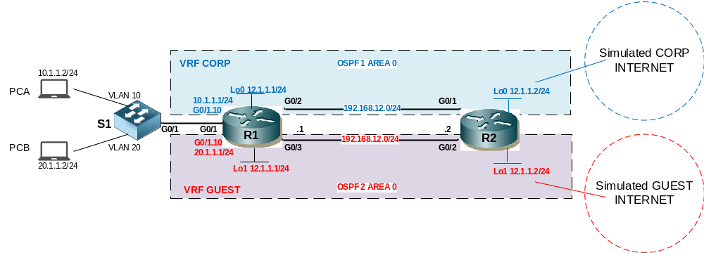
Summary of operation
- VLAN 10 is for CORP users. VLAN 20 is for GUEST users.
- A separate OSPF process will be run within each VRF. OSPF will advertise the VLAN networks from R1 to R2 and the Internet networks from R2 to R1 for each VRF.

IP Addressing
Interface | IP Address | VRF | Notes
R1 G0/1.10 | 10.1.1.1/24 | CORP | VLAN 10
R1 G0/1.20 | 20.1.1.1/24 | GUEST | VLAN 20
R1 G0/2 | 192.168.12.1/24 | CORP | Physical link to R2
R1 G0/3 | 192.168.12.1/24 | GUEST | Physical link to R2
R1 Lo0 | 12.1.1.1/24 | CORP | OSPF router-id
R1 Lo1 | 12.2.2.1/24 | GUEST | OSPF router-id
R2 G0/1 | 192.168.12.2/24 | CORP | Physical link to R1
R2 G0/2 | 192.168.12.2/24 | GUEST | Physical link to R1
R2 Lo0 | 12.1.1.2/24 | CORP | OSPF router-id
R2 Lo1 | 12.2.2.2/24 | GUEST | OSPF router-id
R2 Lo2 | 208.200.200.1/16 | CORP | Simulate Internet
R2 Lo3 | 208.200.200.1/16 | GUEST | Simulate Internet
PCA | 10.1.1.2/24 |  | Default GW = 10.1.1.1
PCB | 20.1.1.2/24 |  | Default GW = 20.1.1.1

Step 1 - Physical
- Physically cable the lab as per the above diagram using 1841 / 1941 routers, 2960 switches and Ethernet straight through and crossover cables. If in VIRL use IOSv & IOSvL2 nodes, the PCs can be simiulated with IOSv routers.

Step 2 – VLANS & Trunk on S1
- Configure VLANs 10 & 20 on S1
- Configure the PCA interface in VLAN 10 & PCB in VLAN 20
- Configure Fa0/1 as a Trunk that only carries VLANs 1, 10 & 20

Step 3 – VRFs on R1
- Configure VRFs on R1 as per the following table (Note it is important to define the VRFs before configuring IP addresses as attaching a VRF to an interface will remove its IP address)
VRF Name | Route Distinguisher
CORP | 100:100
GUEST | 200:200

ip vrf corp
rd 100:100

ip vrf GUEST
rd 200:200

- Configure R1 G0/1.10 subinterface as a member of VRF CORP
interface g0/1.10
ip vrf forwarding CORP

- Configure R1 G0/1.20 subinterface as a member of VRF GUEST
- Configure R1 G0/2 as a member of VRF CORP
- Configure R1 G0/3 as a member of VRF GUEST
- Configure R1 Lo0 as a member of VRF CORP
- Configure R1 Lo1 as a member of VRF GUEST

Step 4 – VRFs on R2
- Configure VRFs on R2 as per the following table (Note it is important to define the VRFs before configuring IP addresses as attaching a VRF to an interface will remove its IP address)
VRF Name | Route Distinguisher
CORP | 100:100
GUEST | 200:200

- Configure R2 G0/1 as a member of VRF CORP
- Configure R2 G0/2 as a member of VRF GUEST
- Configure R2 Lo0 as a member of VRF CORP
- Configure R2 Lo1 as a member of VRF GUEST

Step 5 – IP addressing on R1 & R2
- Configure R1 G0/1.10 & G0/1.20 subinterfaces and IP addresses (remember dot1q encapsulation for VLANS 10 & 20). Ensure the interfaces are operational.
- Configure R1 G0/2, G0/3 and Loopback addresses as per the diagram / IP table.
- Configure R2 G0/1, G0/2 and Loopback addresses as per the diagram / IP table.

Step 6 – Configure OSPF
- Configure OSPF for VRF CORP and VRF GUEST. Ensure each OSPF runs a separate process (locally significant) for each VR. Process 1 for CORP & process 2 for GUEST. Ensure the correct loopback is configured as the OSPF router-id for each process.
router ospf 1 vrf CORP
router-id ...

router ospf 2 vrf GUEST
router-id ...

- Ensure R1 G0/2 & R2’s G0/1 interface networks are added to OSPF process 1 vrf CORP. This will cause the OSPF adjency to establish
- Ensure R1 G0/3 & R2’s G0/2 interface networks are added to OSPF process 2 vrf GUEST. This will cause the OSPF adjency to establish
- Ensure R1’s G0/0.10 (VLAN 10) subinterface network is added to OSPF process 1 vrf CORP
- Ensure R1’s G0/0.20 (VLAN 20) subinterface network is added to OSPF process 2 vrf GUEST
- Confirm OSPF adjacencies & route tables
show ip route vrf corp
show ip route vrf guest
show ip ospf 1 neighbor
show ip ospf 2 neighbor

Step 7 – Advertise Internet loopbacks via OSPF
- Configure Lo2 & Lo3 interfaces on R2. Ensure to add them to the correct VRF and configure their IP addresses
- Configure both OSPF processes on R2 to orginate a default route
router ospf 1 vrf CORP
default-information orginate always

router ospf 2 vrf GUEST
default-information orginate always

Note the ‘always’ key word will cause OSPF to advertise a default route even though it does not have a default-route in its route table.

Step 8 – Confirm connectivity
- Configure the PC IP addresses and default gateways. Note if using VIRL, configure IOSv nodes to act as PCs, configure each with a default-route pointing at the relevant R1 subinterface IP address.
- Confirm the PCs can ping the internet loopback address on R2

